Way 1-Downloadable file
- Go to the page where you want to add the document
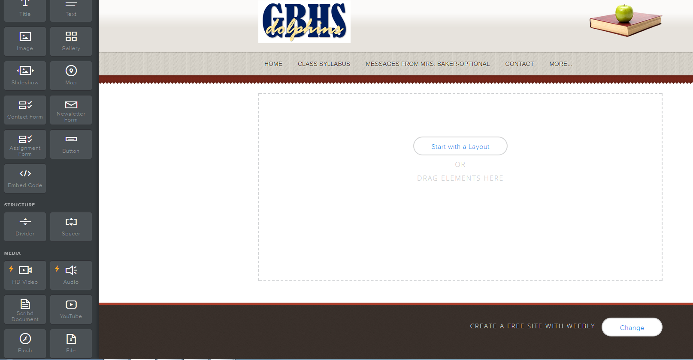

- Drag File to the center of the page and then click “click here to upload file”
- This box pops up and you click “Upload File”
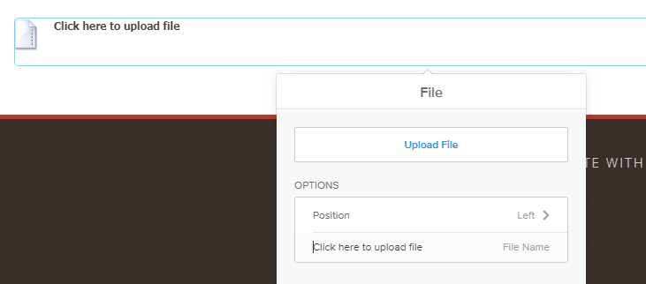

- Choose a file and it will be downloadable.
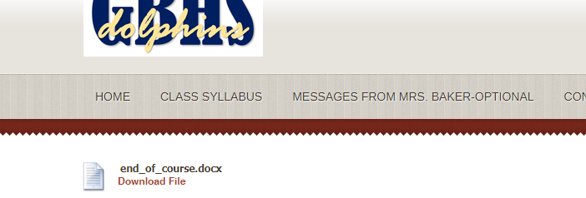
- Publish!

Way 2- Viewable file that can also be downloaded

- Go to the page where you want to add the document, Drag Scribd Document to the center of the page.

- Choose your file and upload.
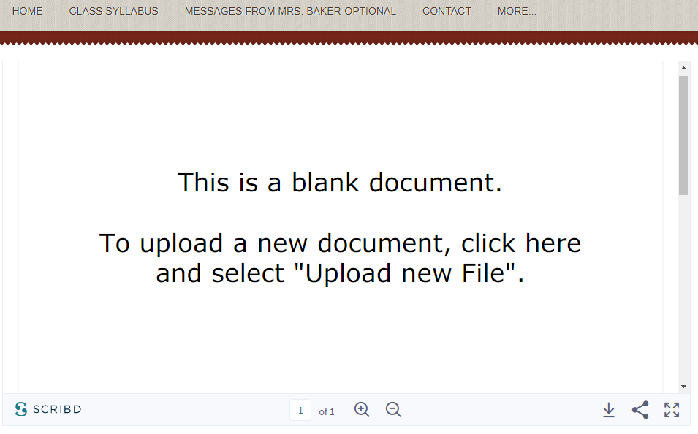

- You will see the document converting screen (sometimes in lingers a long time- don’t worry, just publish and it will show up)

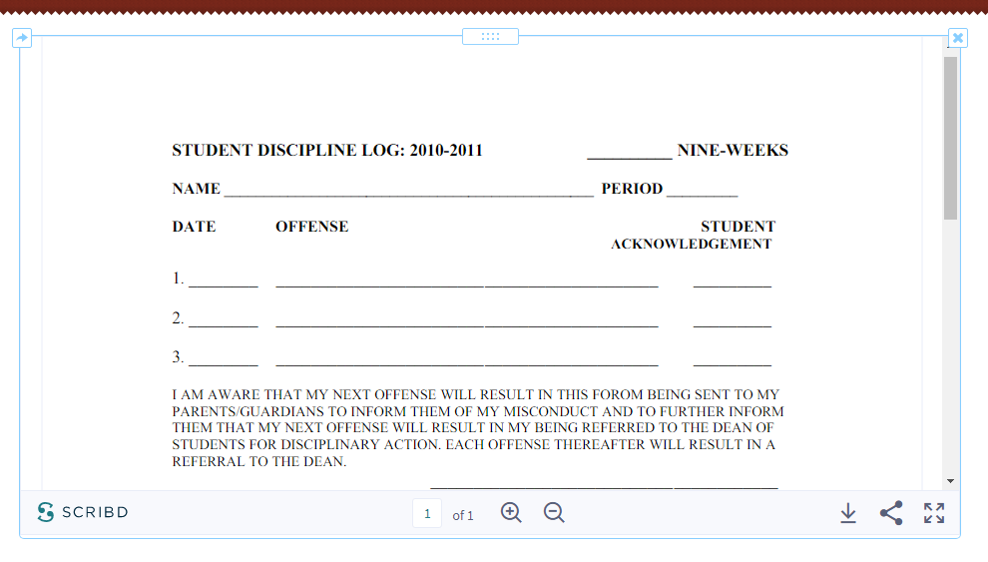
- Publish!

