Adding Remind to my Weebly Page

If you haven’t already created a Remind you’ll need to do so now. This tutorial is for those who already have a remind account.

- Create a Remind page on your website.
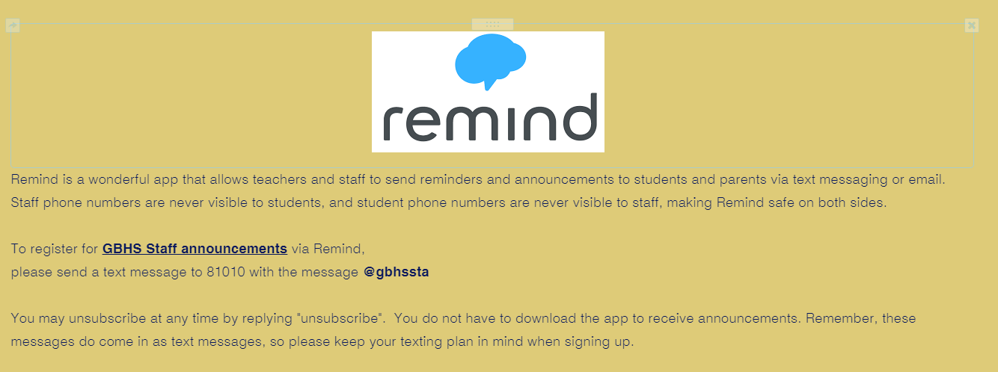

- Open Remind on your computer and click on your name and then account

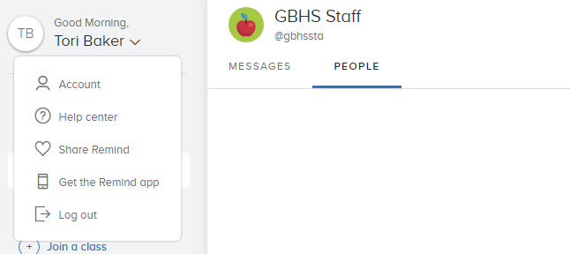

- Now click on Widgets.
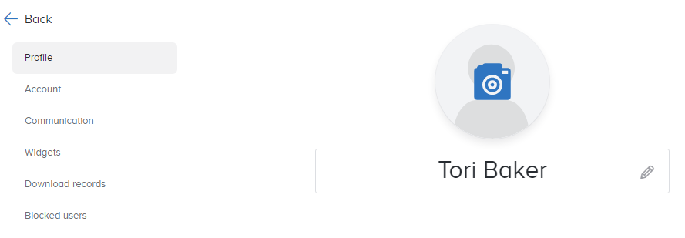

- Click the copy code button
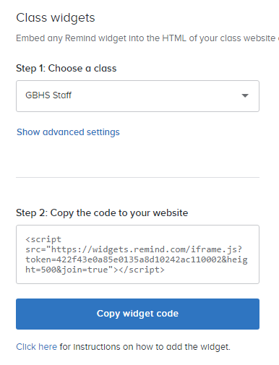
- Back on Weebly’s site drag the embedded code icon onto your page.
- Click the box that says “click to set custom html”

- Click Edit Custom HTML 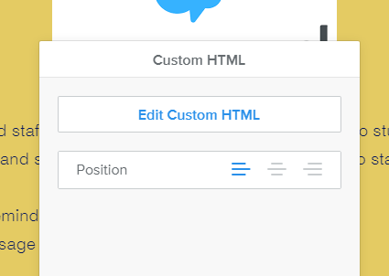

- Paste your copied widget code

- Click off the box and your remind is on your website!
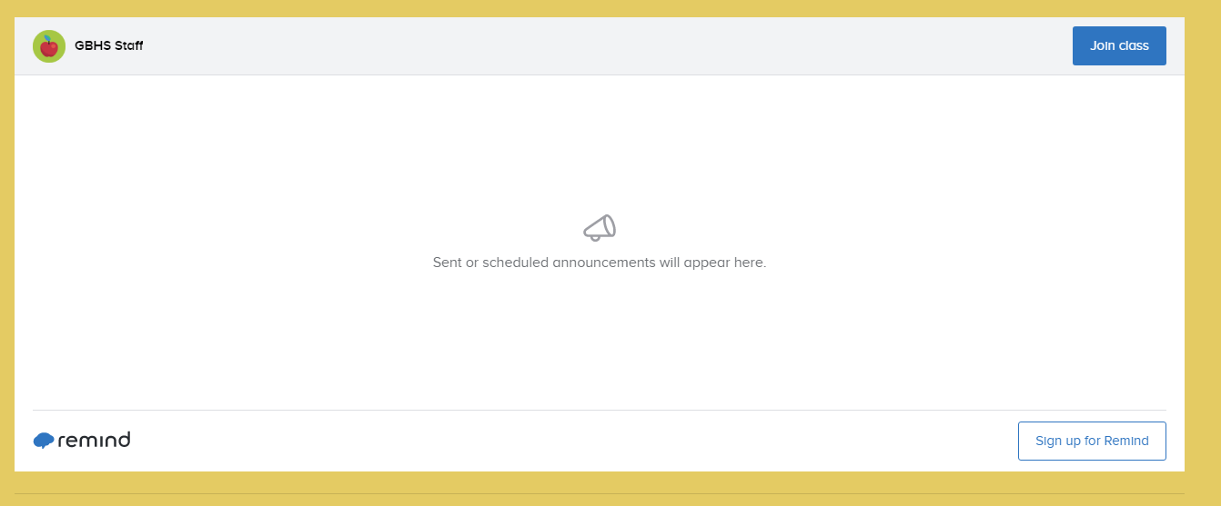

- Don’t forget to Publish.
