If you are interested in creating a site like this one http://gbhstest.weebly.com/
Create a FREE account with www.educationweebly.com Fill in the boxes with a user name, school email and choose a password then click sign up
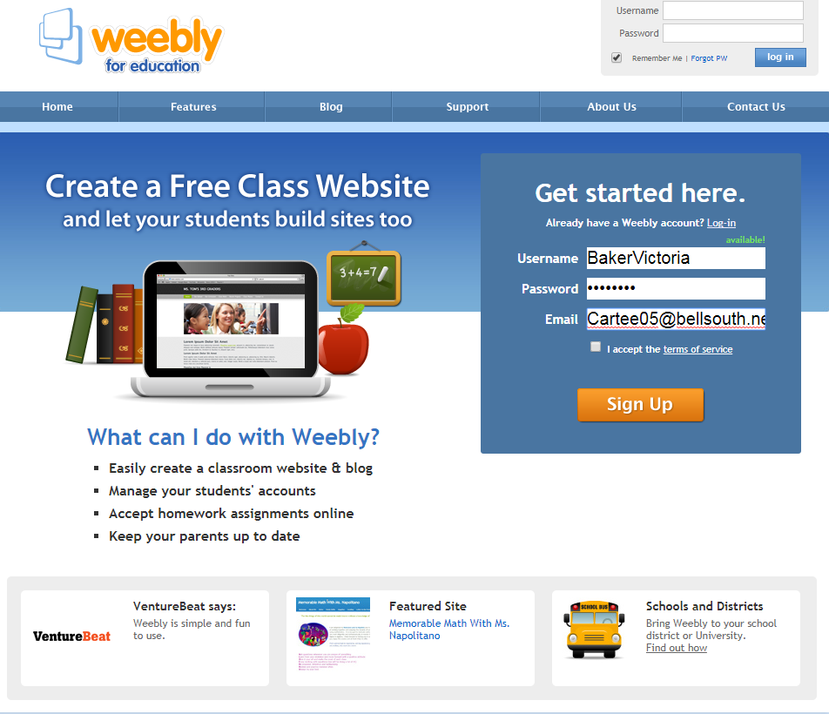
- Enter your info and submit.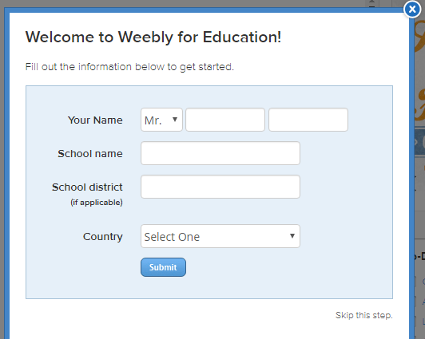
- Click Create a website
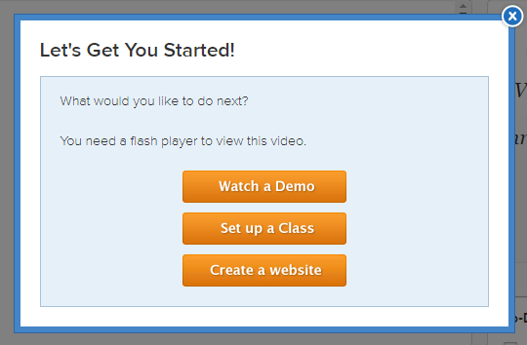
- Selecting a theme is next. Choose anything you like because we are going to change it
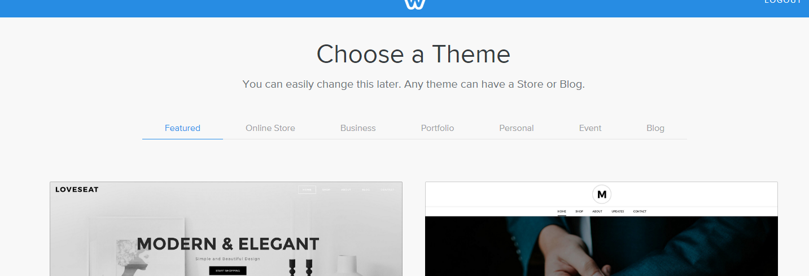

- Now it is time to name your site. Use a Subdomain of weebly.com (it is free). When you’ve chosen something that shows a green arrow and Available, click continue.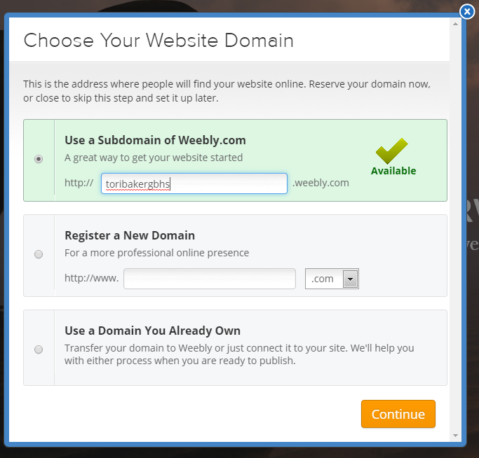

- Now, let’s change your theme to something you like. Click on Theme from the navigation bar.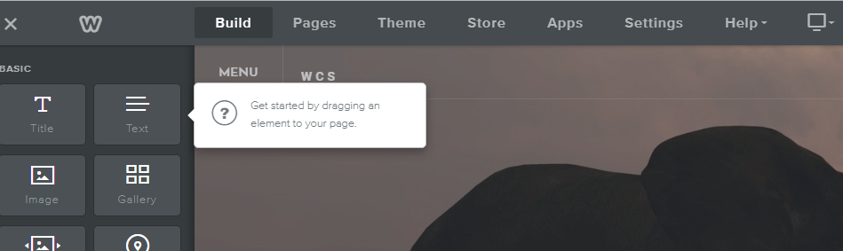

- Click Change Theme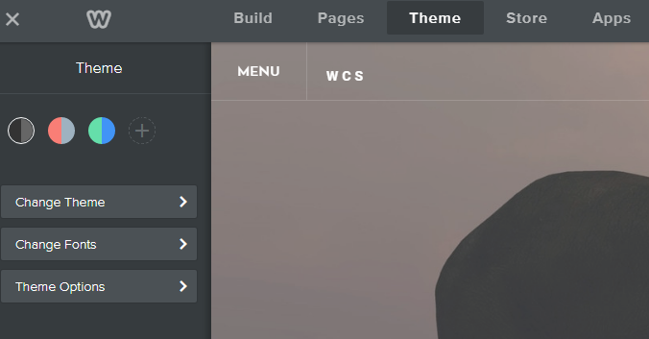

- Now, click Select a theme. If the ones shown are not your style, scroll to the bottom and click “Show old themes”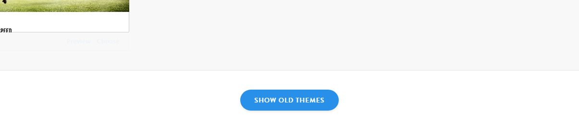

Some of these themes may suit your classroom need better but you can choose whatever YOU like.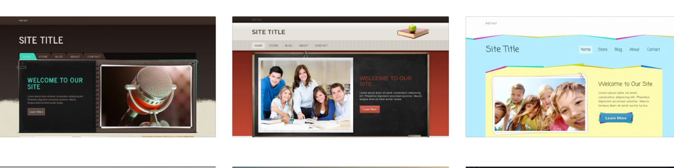
- Once you’ve chosen your new template, it is time to customize your page. Start by selecting PAGES from the navigation bar.

- We are going to delete the shop page since no one is selling anything in their classroom. Click the arrow to the left of “Home”

- Select “Shop” from the list

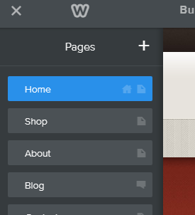

- Select DELETE, Confirm DELETE
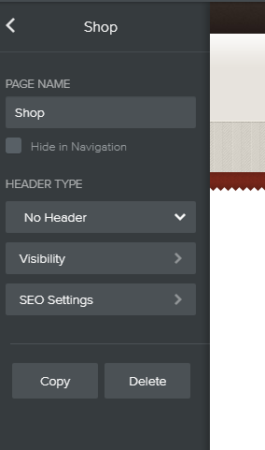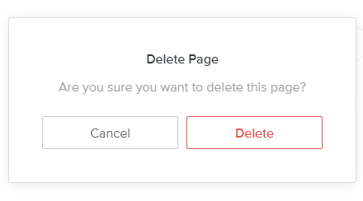

- Next, let’s will rename your “About” page to “Class Syllabus”. From the Pages menu select About. Click in the Page Name box and change the title to Class Syllabus.
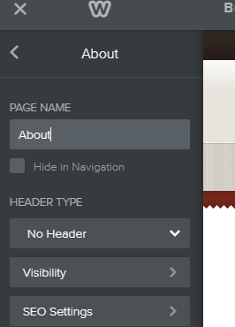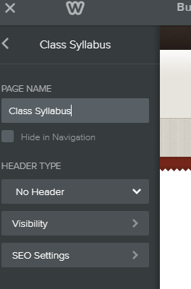

Your basic website has now been created and it is time to add YOU to it.
- The HOME Page
- Options
- AT the Red arrow, create a title for your page and type it here.
- At the Blue arrow, you can write your name or you can put in a logo by clicking here.
- At the Green arrow, we will check out the different kinds of home pages by clicking the grey gear and trying them out. If you don’t have a picture or don’t want a picture, choose no header.

- This is where you will tell a bit about you and your background. You can do this by adding two simple features to your HOME page. Choose BUILD from the navigation bar across the top. Click and Drag Title and Text to the empty rectangle.
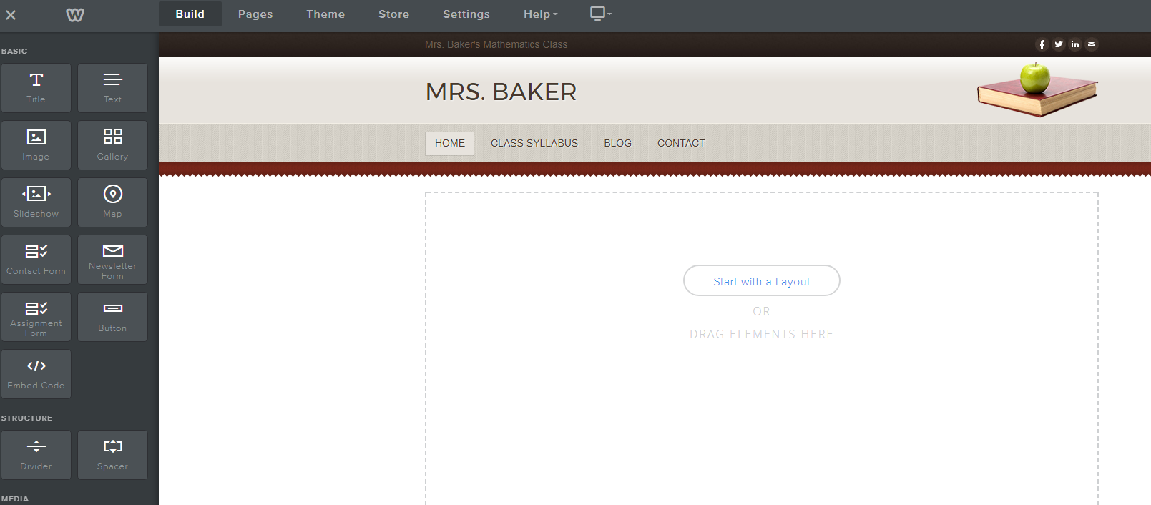

- Now you should have a place to type a short Bio about you.
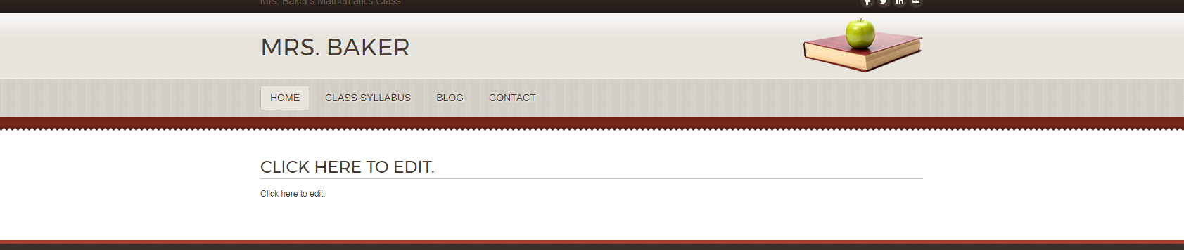

Make it simple.
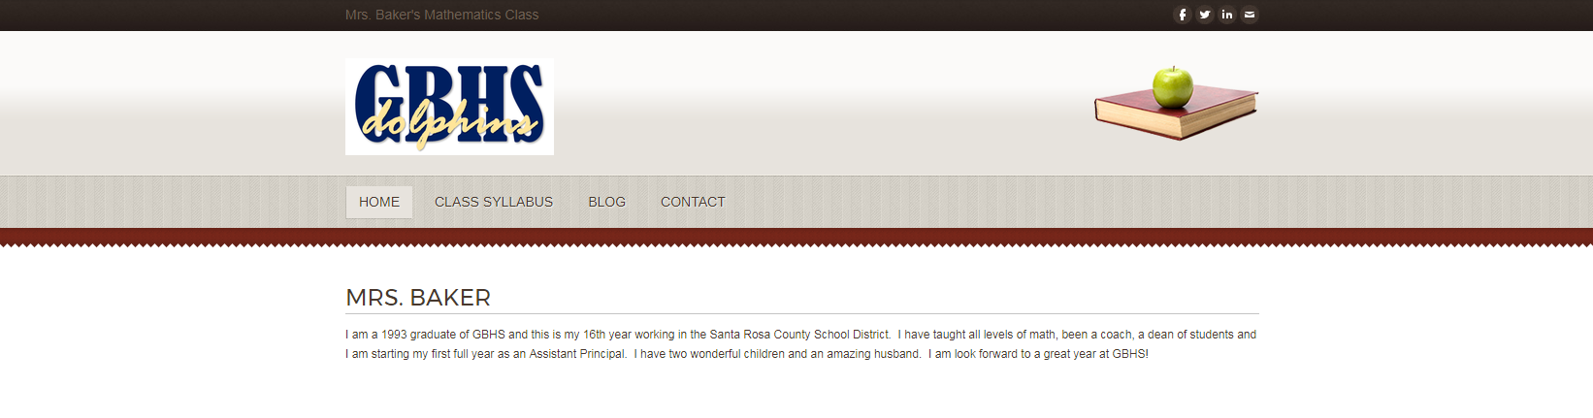
Or add more if you are so inclined!
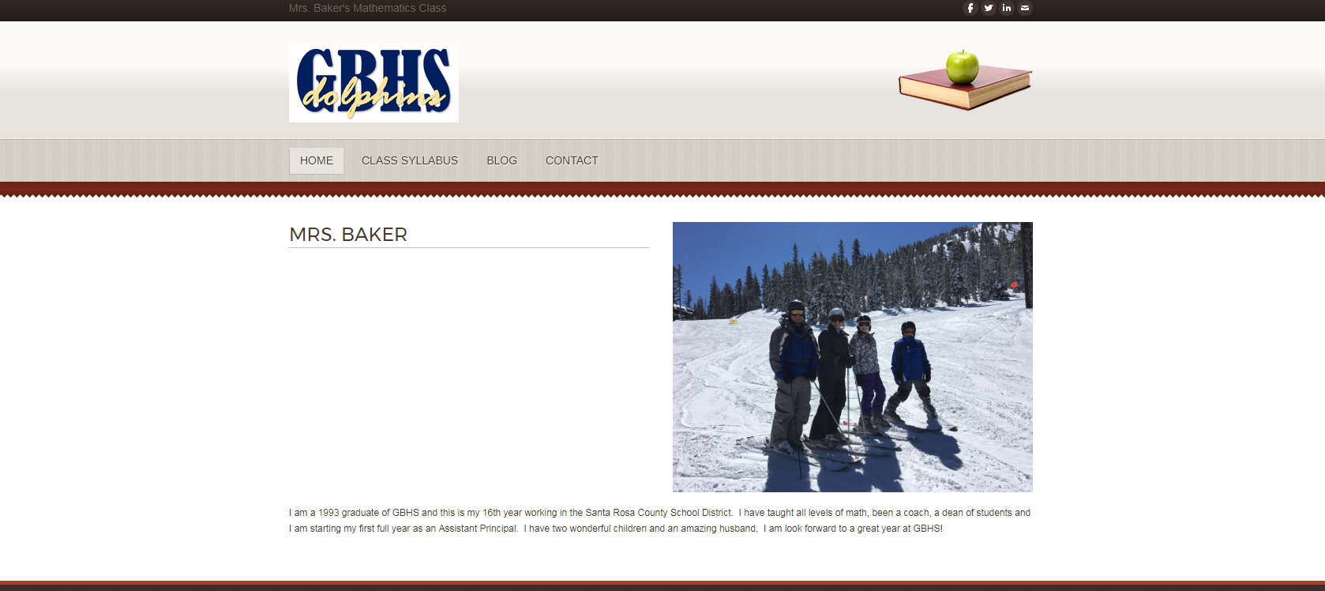

- On to the next page, Class Syllabus.
- Click on Pages and choose class syllabus
- Choose the BUILD menu and add Title and File to the page
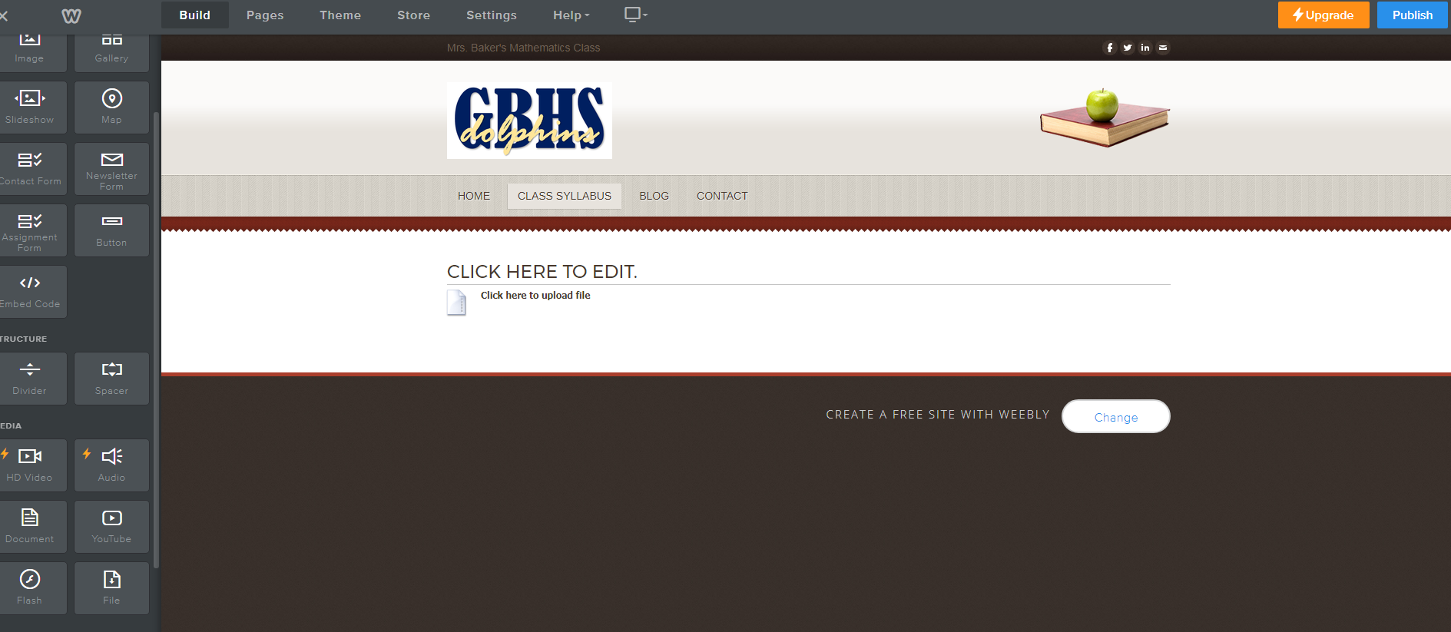

- Add the title of your course and upload the syllabus.
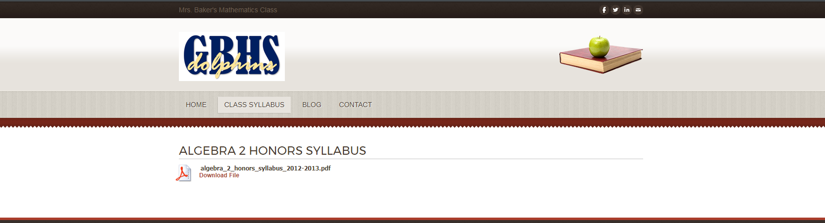

- If you teach more than one course, repeat this process to include the syllabi from all of your courses.

- Contact Page Two options: a. simple, b. more advanced.
SIMPLE WAY
- Add title and text from the build menu
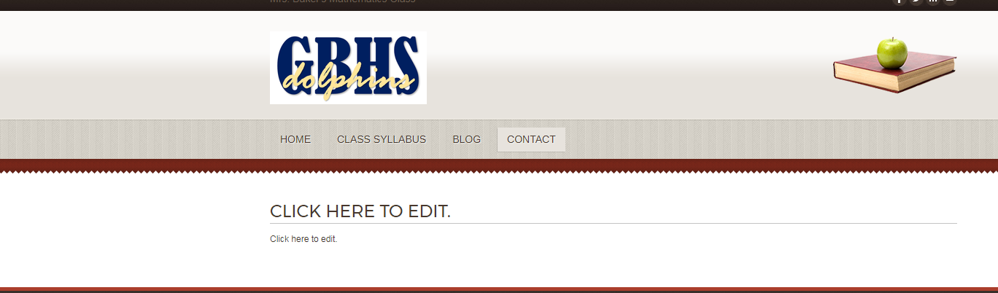

- Put in your information.
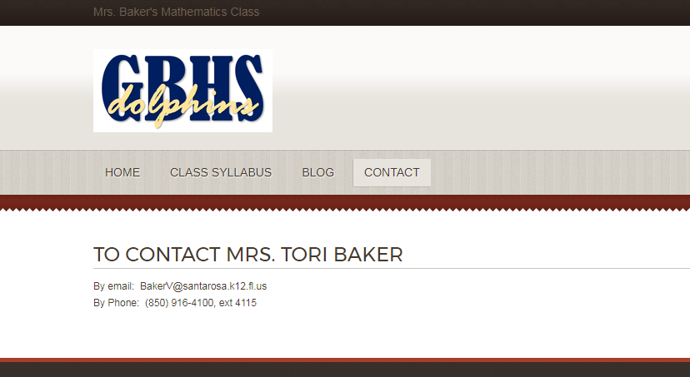

MORE ADVANCED WAY

- Click Start with a layout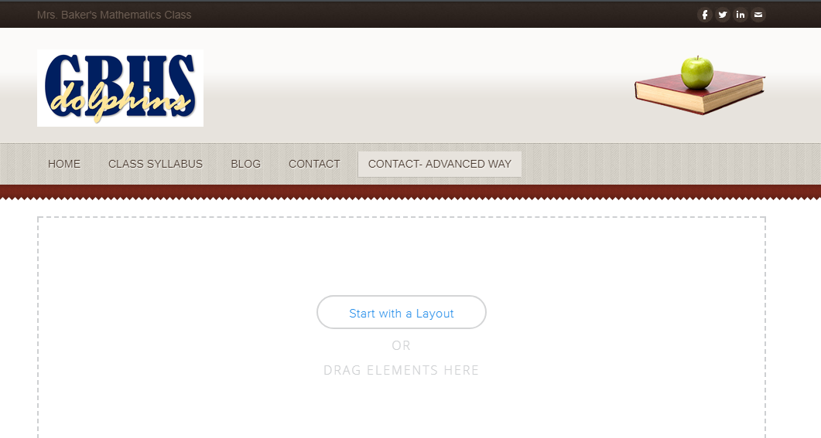

- Choose CONTACT and then choose the first layout

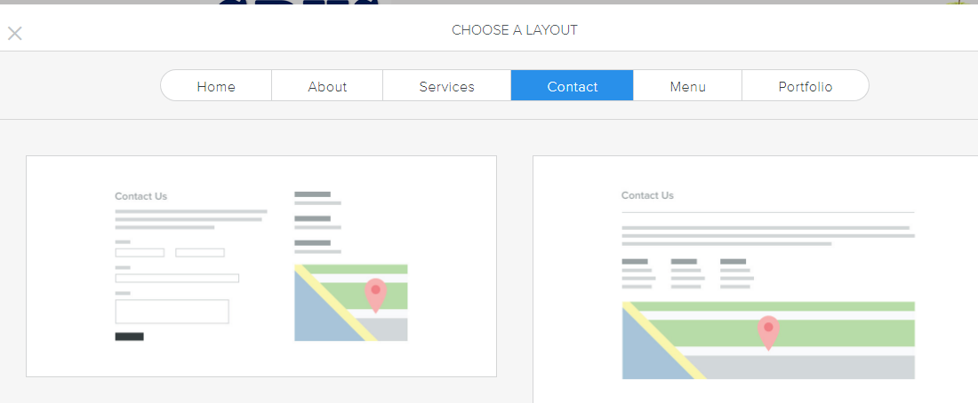

- Choose Keep

- Type in your information
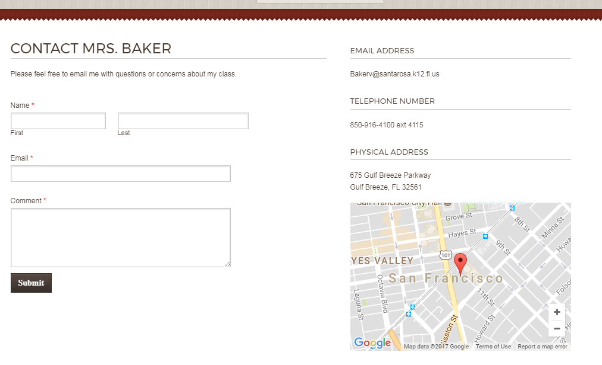
The email submission and the map will require just a few more steps.

- Click the submit button and then choose the form options.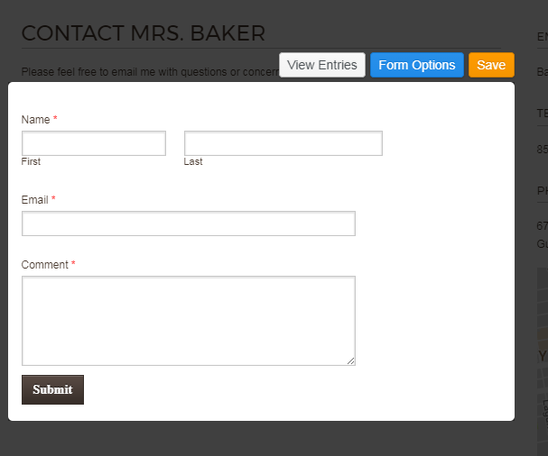

- You will need to put your email in for the Email to and click Save.
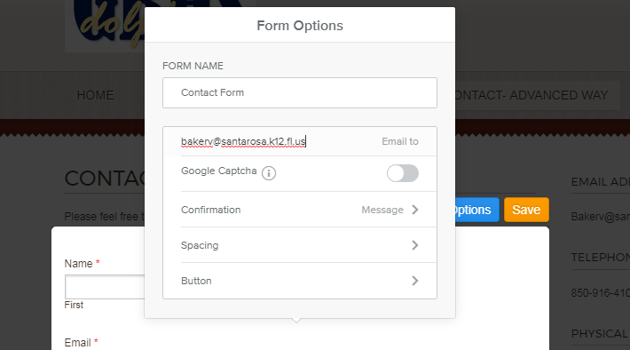

- Click on the map and put in GBH’s address 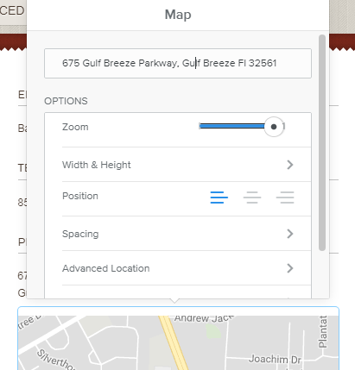

Your contact page is complete.
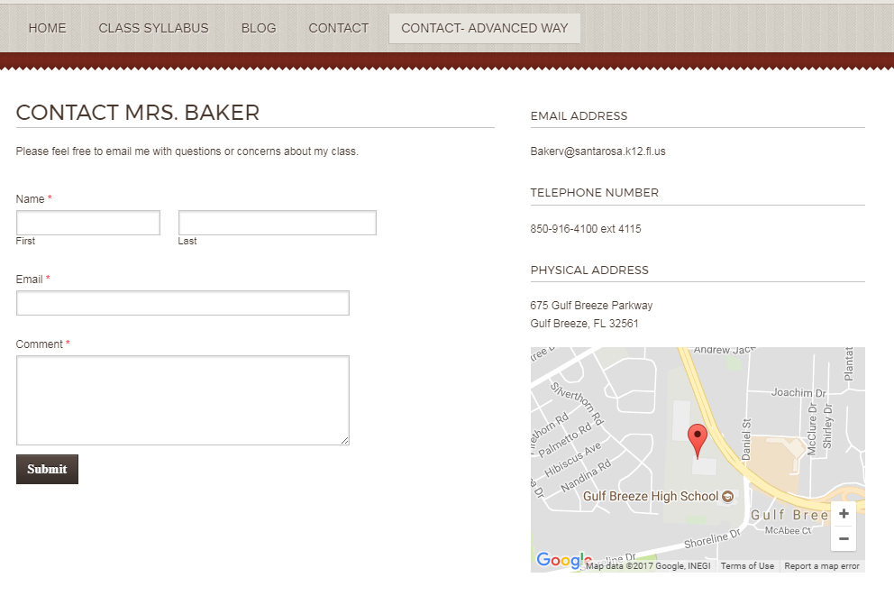

***If you don’t want to add assignments or posts regularly then DELETE the BLOG page. If you would like to post schedules or assignments or reminders, continue on and modify the BLOG page.

BLOG page (Assignments, schedules, reminders, etc.)

- Give the page whatever title you’d like
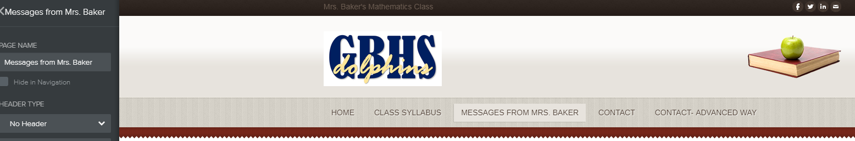

- The BLOG page comes with this standard layout. Let’s make some changes by choosing the settings button at the bottom. 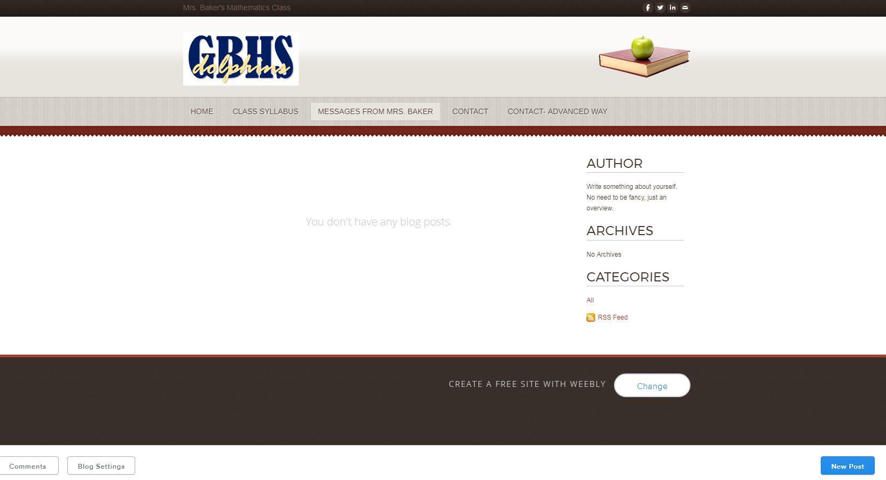
- For basic use, Turn off post share and blog sidebar and change the Comment default to closed and CLICK SAVE.
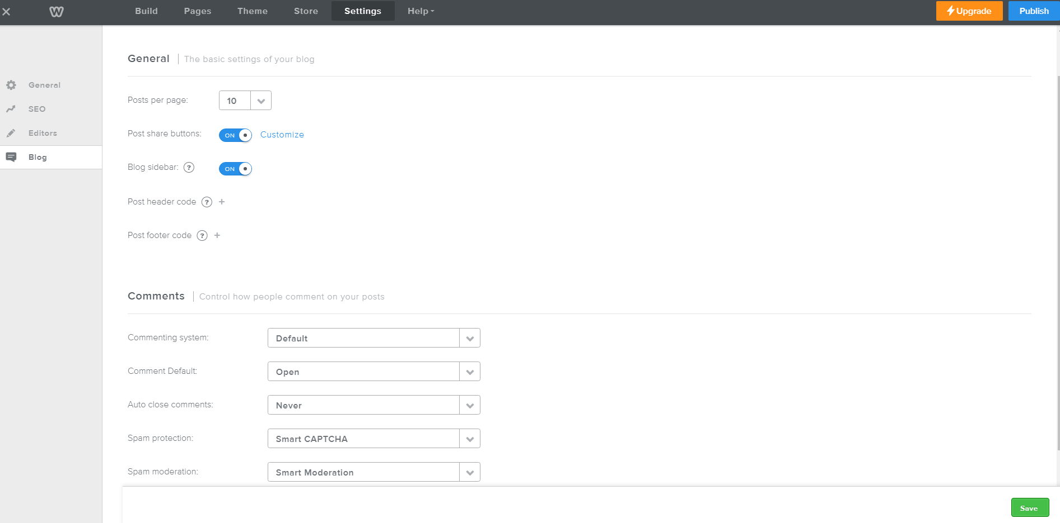
- Click on Pages to go back to your page. Now it is much cleaner and simpler.
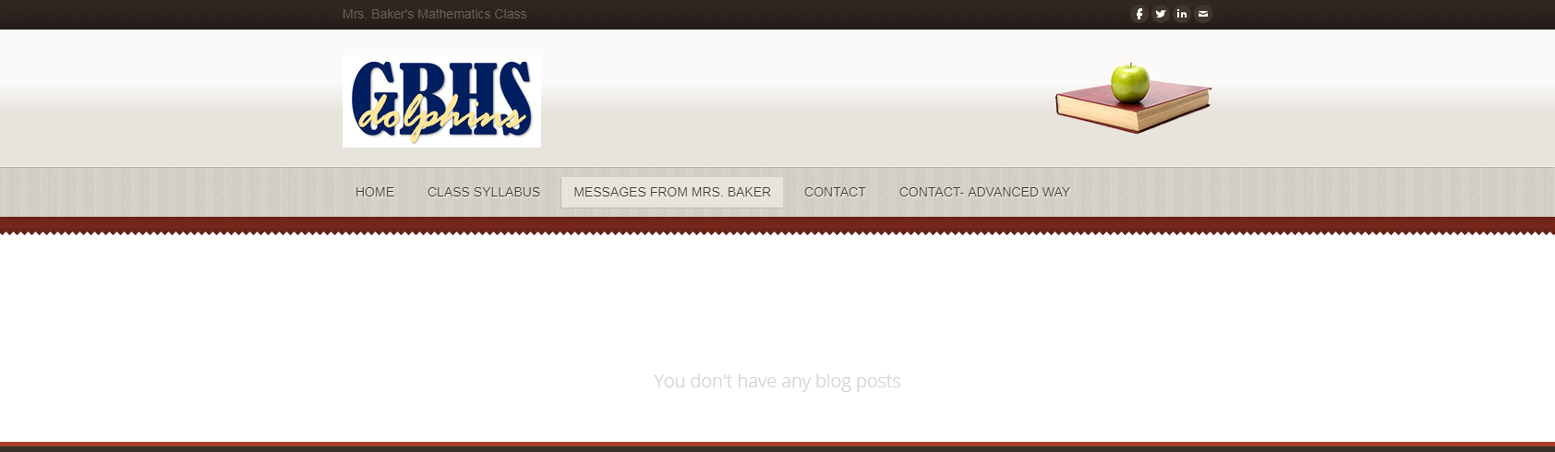
- Add a post! Click the blue new post button in the bottom right hand corner.

- As before, you can type in the title area and drag anything into the box to share.
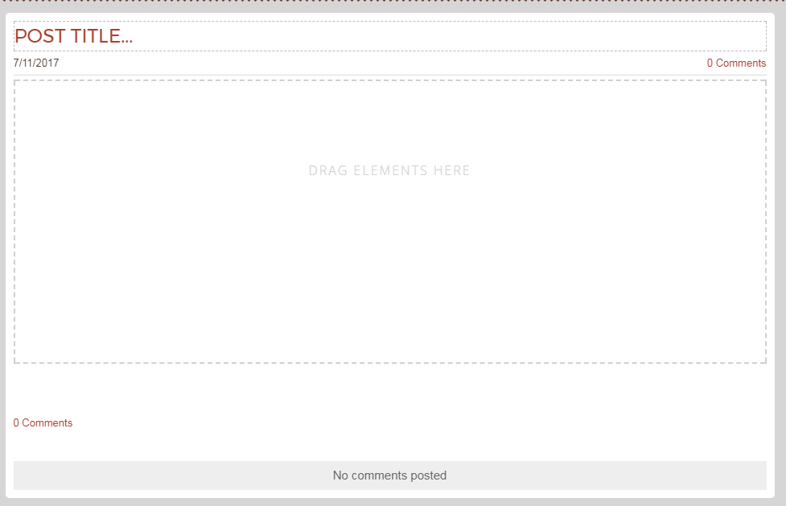
For example,
Class Notes
A youtube video tutorial
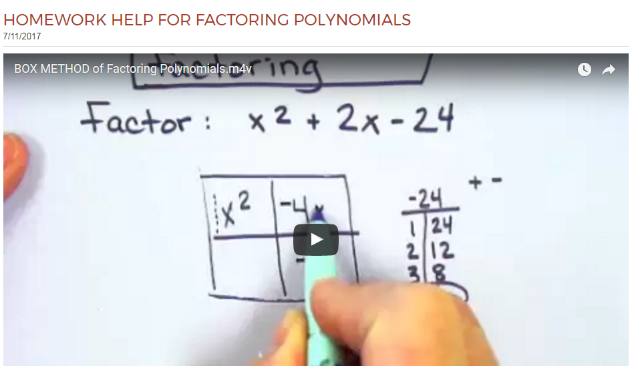
Reminder of a quiz and a picture of the material
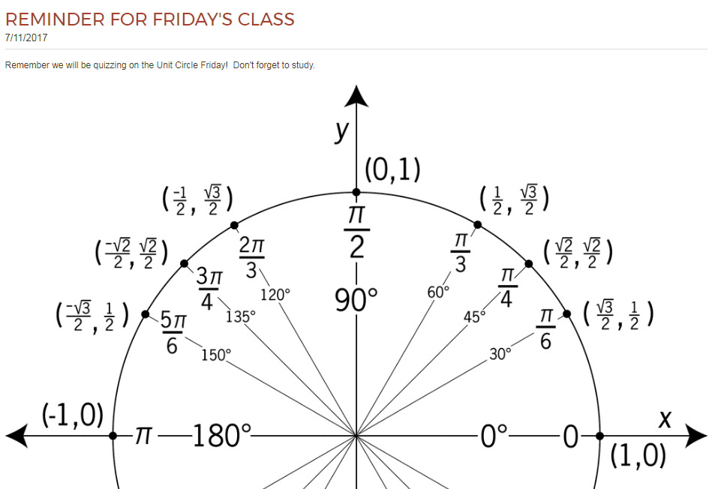
Quizlet Link
Changing the Theme- Your page is done but maybe you want to see what it would look like with a different theme or color combination…
- Click Theme from the top navigation bar.
You can change the color of your current theme by selecting the colored dots.
You can also change the fonts from this page.

- If you want to see a different theme altogether then select change theme and explore your options.
  - Choose Preview and you can see your present content in another format. The preview is interactive so you can check out all your pages.
  - If you find something you like better simply click the blue CHOOSE box.

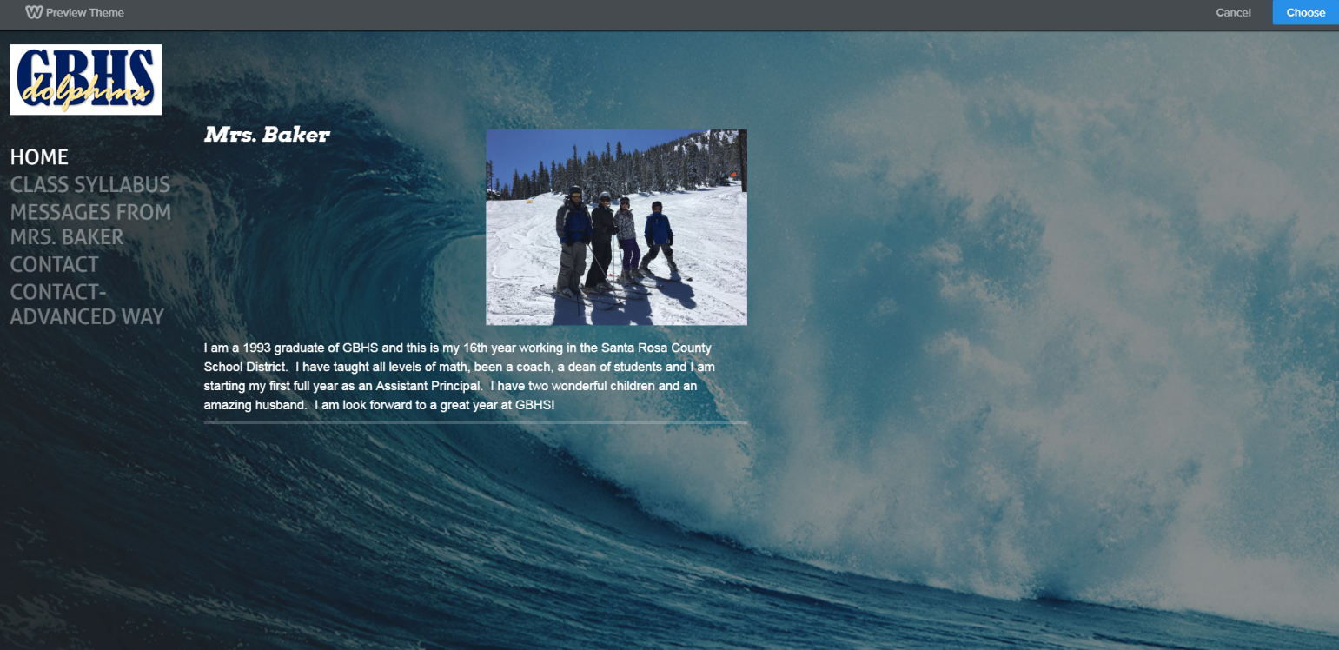
Adding Remind to my Weebly Page

If you haven’t already created a Remind you’ll need to do so now. This tutorial is for those who already have a remind account.

- Create a Remind page on your website.
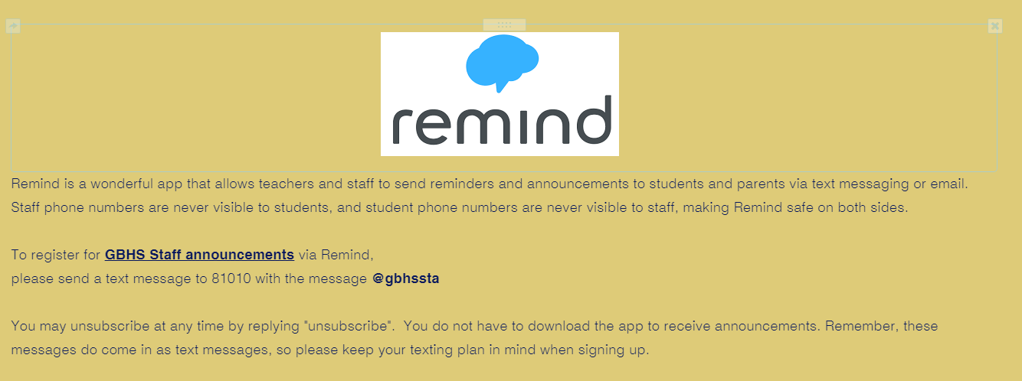

- Open Remind on your computer and click on your name and then account

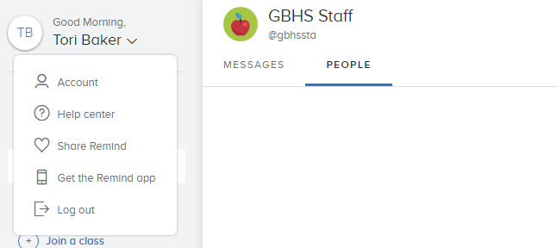

- Now click on Widgets.
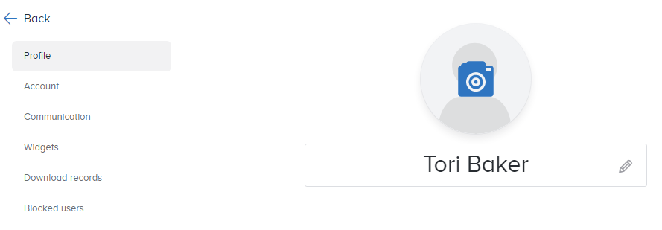

- Click the copy code button
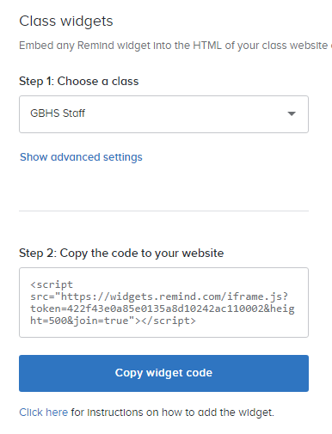
- Back on Weebly’s site drag the embedded code icon onto your page.
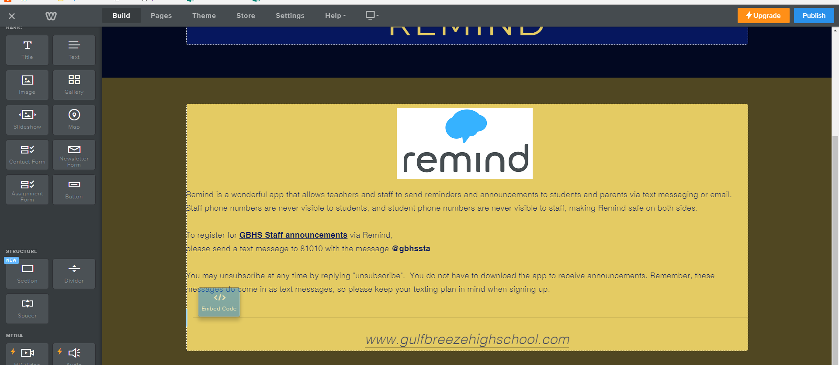
- Click the box that says “click to set custom html”

- Click Edit Custom HTML 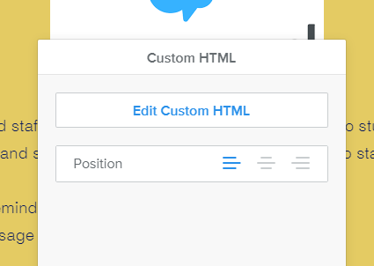

- Paste your copied widget code

- Click off the box and your remind is on your website!
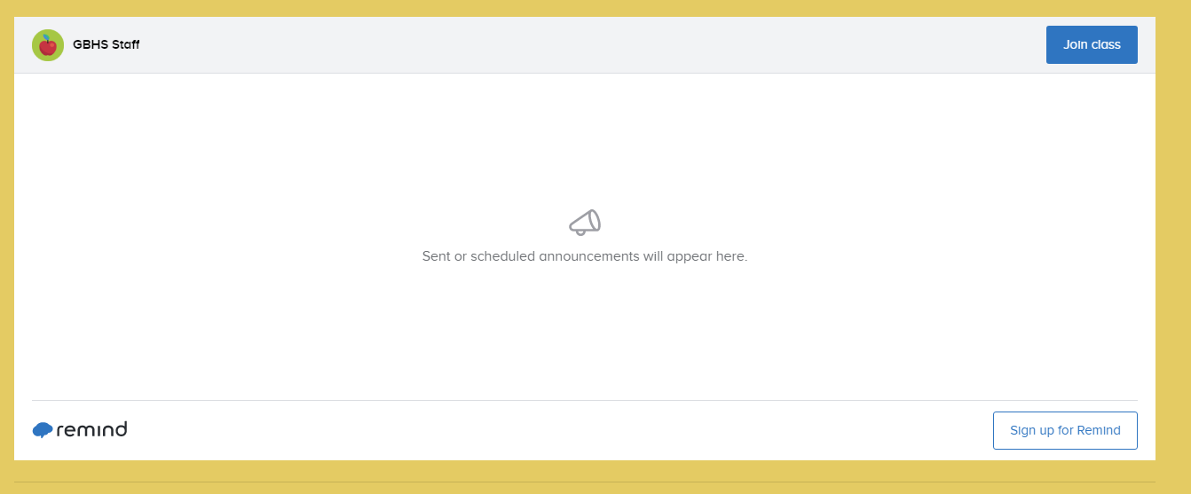

- Don’t forget to Publish.
