Signing up a Remind account and setting up a class in Remind
- Go to Remind.com on your computer and create an account by clicking sign up.
- Once you’re in you will Create a Class by clicking the + sign.
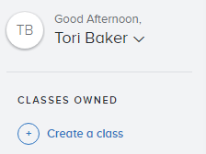
- This box pops up where you can name your class. The class code auto populates but you can change it to whatever you like. Choose your school and click create.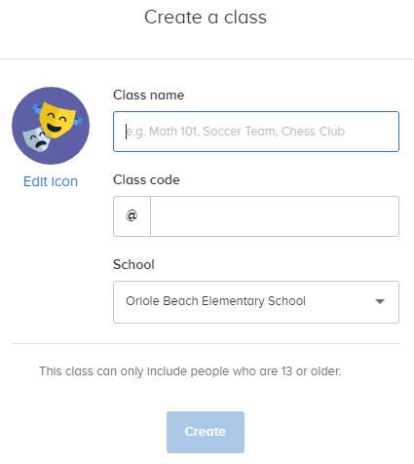

- The next screen allows you to choose how to share your remind. I think IN PERSON INSTRUCTIONS is the easiest. Students and parents can text your class code to 81010 and they will be a part of your class.
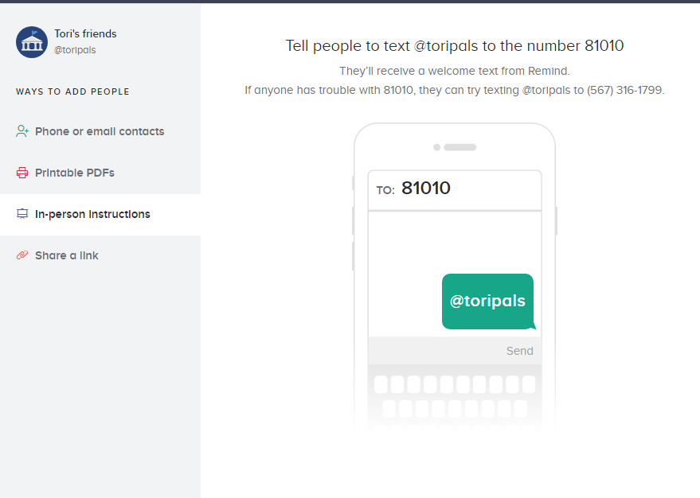

That’s it! You can send out messages via remind now about homework, tests, or whatever is going on in your class.

If you want to have separate Remind stream for
different courses just create a new class.

